Contents

1. Electronic Data Interchange(EDI) 2

Definition 2

Usage: 2

System requirement: 3

Idoc structure: 3

1. ORDERS: 4

1.1. Enhancements: 5

2. ORDRSP: 6

2.1. Enhancements: 8

3. DESADV: 9

3.1. Enhancements: 11

3.2. Mapping enhancements: 13

4. INVOIC: 13

1. Enhancements: 15

Enhancement for Batch.co.uk: 17

# Electronic Data Interchange(EDI)

Definition**:** EDI (Electronic Data Interchange) is the electronic exchange of business documents: between the computer systems of business partners, with a standard format over a communication network.  
  
This interface can be used to do the following:

* Send messages (outbound processing) such as an order confirmation through Electronic Data Interchange (EDI).
* Receive messages (inbound processing) such as a sales order through EDI

The message types that we use are:

* ORDERS(INT-137)🡪 Inbound message
* ORDRSP(INT-133)🡪 Outbound message
* DESADV(INT-130) 🡪 Outbound message
* INVOIC(INT-131) 🡪 Outbound message
* CREHDR(INT-128) 🡪 Outbound message
* DELHDR(INT-129) 🡪 Outbound message

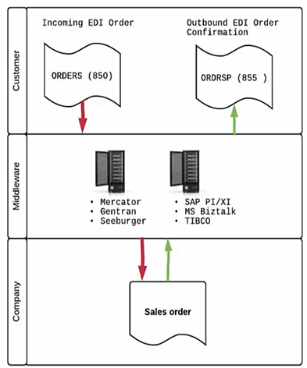

## Usage:

1. ORDERS: This message type is used to receive orders from the EDI partners to SAP
2. ORDRSP: This message type is used to send the order acknowledgement from SAP system to the EDI partners system.
3. DESADV: This message type is used to send the advanced shipping notifications from SAP system to the EDI partners system.
4. INVOIC: This message type is used to send the invoice details of the sales order from SAP to other EDI partners system.
5. CREHDR: This message type is used to send the invoice details of the credit memo from SAP to the EDI partner system.
6. DELHDR: This message type is used to send the delivery notice with invoice from SAP to the EDI partner system.

## System requirement:

* Sender Port & Receiver ports are to be maintained at system level to send or receive orders. The port details will be configured by BASIS team.
* Partner profile for the partners to send/receive inbound/outbound messages. This is to be setup using T-code: WE20 by OTC consultant.

## Idoc structure:

Every idoc(intermediary document) in SAP will comprise of the below records.

* Control record: This will contain informations of sender & receiver details like port, partner number/id, partner type(KU), partner role(SP)

* Data record: This will contain header data & line item dataA screenshot of a computer

  Description automatically generated
* Status record: This will contain the different status a particular idoc has gone through with the time details. A screen shot of a computer

  Description automatically generated

**Idoc status:**

|  |  |
| --- | --- |
| Status | 50- Idoc added 64- Idoc ready to pass to application 62- Idoc passed to application 53- Application posted 51- Application failed to post with error message 56- EDI partner profile does not exist  74- Idoc created by test txn |

# ORDERS:

* It is basically the inbound idoc which would be used to create orders for EDI partners in SAP system
* It will consists of order type, po type, order date, partner details, materials required, quantity of materials.
* Mandatory values required for order creation in SAP system are Customer, Sales area, order type, material, Quantity.
* For ORDERS file to get successfully passed to the SAP system and create a sales order, the process code & the function module for the process code are made use of. The process code can be seen in Partner profile for ORDERS message.
* Process code: ORDE  
  Function module: IDOC_INPUT_ORDERS
* **Idoc sample:** 21794652(Sx3-420)
* **Message structure:**
  + Every header data segments are mentioned using E1EDK-- segment
  + Every line item data are maintained using E1EDP—segment

|  |  |
| --- | --- |
| ORDERS | E1EDK01- Order header details |
|  | E1EDK02- PO number(001) |
|  | E1EDK14- details like DC(007), Order type(019/012), Sales org(008), Division(006) |
|  | E1EDK03- Dates like order date, customer ref date(012), Shipping date(106) |
|  | E1EDKA1- Partner details AG- Sold-to party; RE- Bill-to; RG- Payer; WE- Ship-to |
|  | E1EDK17 001/002- Inco terms |
|  | E1EDK18 001/002- Payment terms |
|  | E1EDP01- Line item data  E1EDP19- Material data |
|  | E1EDP05- Line item price |

The following are the sample XML file and mapping sheet for the same.

 

## Enhancements:

* For few partners like Academic books, Maruzen etc.., requirement was to update different Customer PO reference values for every line item instead of using the Customer PO reference same as header in a single order.
* To achieve this, an update was made in the INT-137 mapping for those partners to make use of qualifier ‘044’ instead of ‘001’ at line item level for segment E1EDP02 under E1EDP01
  + 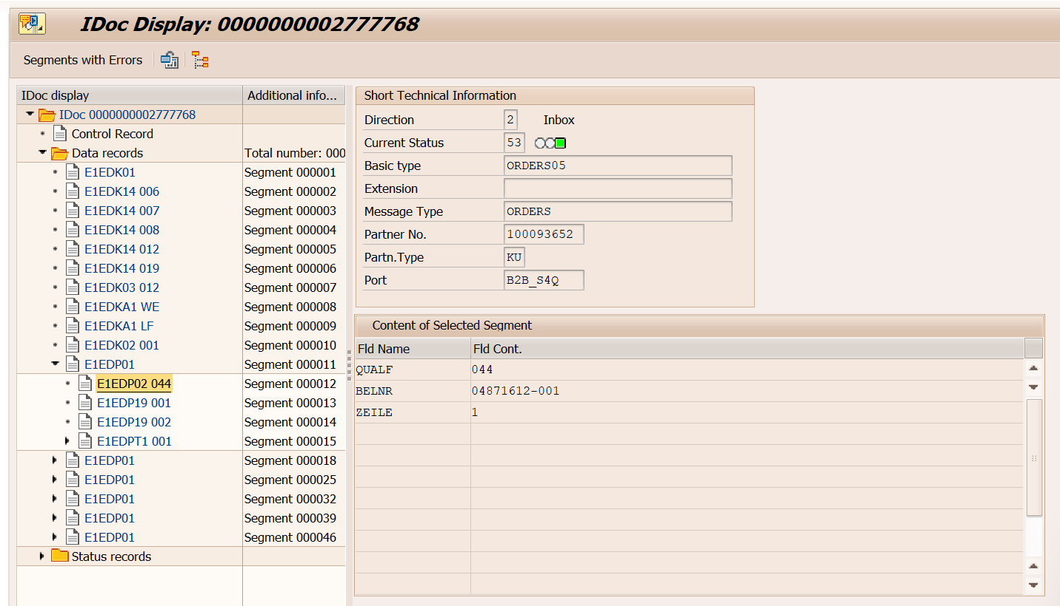Sample order: 5221 in S4Q-220
* For other partners, the Customer PO reference at both header & item level will be the same where E1EDP01/E1EDP02 has Qualifier as ‘001’   
   Sales Order: 330 in S4Q-220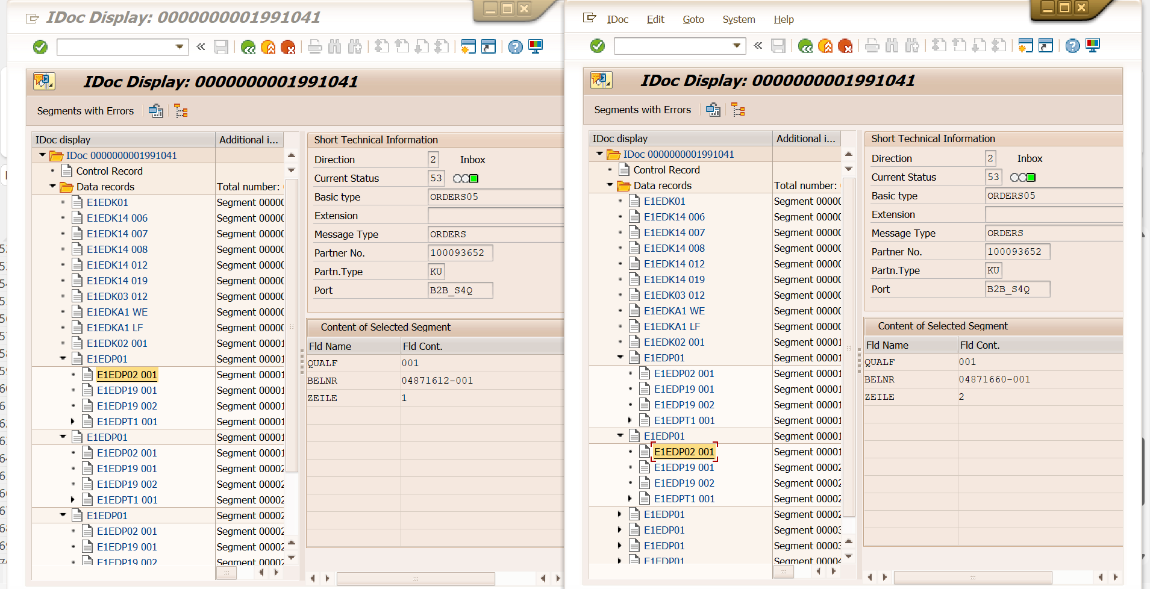
* INT-137 Mapping sheet: [EDI-10_INT-137](https://cognizantonline.sharepoint.com/:f:/r/sites/OUPS4Transformation/Shared%20Documents/General/03%20-%20Realize%20Phase/03%20-%20OTC%20SALES/SIT/Mapping%20Sheet/EDI/EDI-10_INT-137?csf=1&web=1&e=9Jw7gx)

# ORDRSP:

Process code: SD10  
Function module: IDOC_OUTPUT_ORDRSP

* It is basically the outbound idoc which would be used to send acknowledgement for the sales orders creation in SAP. It will be sent from SAP to the respective partners via EDI
* It will consists of order type, po type, order date, partner details, materials required, quantity of materials.
* **Message structure:**
  + Every header data are mentioned using E1EDK-- segment
  + Every line item data are maintained using E1EDP—segment

|  |  |
| --- | --- |
| ORDRSP | E1EDK01- Order header details like Order number |
|  | E1EDK14- details like DC(007), Order type(012), Sales org(008), Division(006) |
|  | E1EDK03- Dates like order date, customer ref date |
|  | E1EDKA1- Partner details AG- Sold-to party; RE- Bill-to; RG- Payer; WE- Ship-to |
|  | E1EDK17 001/002- Inco terms |
|  | E1EDK18 001/002- Payment terms |
|  | E1EDP01- Line item data  E1EDP19- Material data |

* **Sample idoc:** 2778181 from S.O 5271 in S4Q-220A screenshot of a computer

  Description automatically generated

Partner profile:

T-code: WE20

## Enhancements:

* A logic was extended from Amazon to Baker & Taylor accounts to add ZOTC_ZE1EDP20 under E1EDP01 with Qualifier as ‘PRT’ mentioning the partially confirmed quantity in additional to Qualifier ‘FULL’ (fully confirmed) & ‘NOT’ (not confirmed) A screenshot of a computer

  Description automatically generated
* For Baker & Taylor VIP partner, the requirement is to cancel the line item and assign reason for rejection as Backorders not allowed when there is partial confirmation on the ordered quantity.  
  Sample order:   
  5271(S4Q-220) for VIP account(Backorder not allowed)  
  4303(S4Q-220) for GS account( Backorder accepted)

Sample MRS:



* Mapping sheets INT-133: [EDI-6_INT-133](https://cognizantonline.sharepoint.com/:f:/r/sites/OUPS4Transformation/Shared%20Documents/General/03%20-%20Realize%20Phase/03%20-%20OTC%20SALES/SIT/Mapping%20Sheet/EDI/EDI-6_INT-133?csf=1&web=1&e=5wkG4C)

# DESADV:

Process code: DELV  
Function module: IDOC_OUTPUT_DELVRY

* It is basically the outbound idoc which would be used to send Advanced shipping notification for the Delivery creation in SAP. It will be sent from SAP to the respective partner via EDI
* It will consists of Delivery details like Delivery, Delivery date, partner details, materials required, quantity of materials in the delivery, packing details like carton id, tracking number.
* **Message structure:**
  + Every header data are mentioned using E1EDL20 segment
  + Every line item data are maintained using E1EDL24 segment

|  |  |
| --- | --- |
| DESADV | E1EDL20- Has header delivery details like Sp, sales org, Inco terms, route, weight, number of packages, date |
|  | E1EDL22- Description of Shipping point, Sales org, Incoterm, Route, Shipping conditions |
|  | E1EDL21- Delivery type, priority, Transportation group |
|  | E1EDL18/ORI--> Mentions Original idoc |
|  | E1ADRM1 AG--> Has partner address and details AG- Sold-to party; RE- Bill-to; RG- Payer; WE- Ship-to |
|  | E1ADRM1 OSP--> Shipping point details |
|  | E1ADRM1 OSO--> Sales organization address |
|  | E1EDT13 001--> has details like start date & time and end date & time for Transportation planning |
|  | E1EDT13 003--> has details like start date & time and end date & time for Loading |
|  | E1EDT13 006--> has details like start date & time and end date & time for Goods Issue |
|  | E1EDT13 007--> has details like start date & time and end date & time for Delivery |
|  | E1EDT13 010--> has details like start date & time and end date & time for Picking |
|  | E1EDT13 015--> has details like start date & time and end date & time for Document date |
|  | E1EDL33- Destination country |
|  | E1EDL28- Has route, shipping type, route id, distance |
|  | E1EDL24- Line item details like qty, plant, sto. Location, weight, loading & trans group, material |
|  | E1EDL37- Has details like handling unit header details, carton id, tracking Id |
|  | E1EDL44 – Has handling unit Item details within a carton/pallet like material, qty, storage location, plant etc.., |
|  | ZE1EDL44 – This segment has item details including material, customer po(header), customer po(item), qty, UOM |

**Sample Idoc:** Idoc 19872684 in Sx3-420 (Del. Number: 0300000637)

Amazon idoc: 21783332 in Sx3-420(Del. Number🡪 300002318)

**Partner profile:**

Partner type: KU

## Enhancements:

* An Custom segment ZE1EDL44 is created under parent segment E1EDL441 to populate the customer purchase order number value coming from the sales document . This segment contains the field i.e ZBSTKD (already created in S4 HANA).

The below fields needs to fetched in Z-Segment

|  |  |
| --- | --- |
| **Field Name** | **Description** |
| VELIN | Type of Handling-unit Item Content |
| VBELN | Sales and Distribution Document Number |
| POSNR | Item number of the SD document |
| VEMNG | Base Quantity Packed in the Handling Unit Item |
| VEMEH | Base Unit of Measure of the Quantity to be Packed (VEMNG) |
| MATNR | Material Number |
| ZBSTKD | Customer purchase order number |

* Logic for VELIN

Pass VBELN=Delivery Number, POSNR= Delivery item number to the table VEPO and fetch VELIN.

* Logic for VBELN

Pass VBELN=Delivery Number, to the table VEPO and fetch VBELN.

* Logic for POSNR

Pass VBELN=Delivery Number, POSNR=Delivery item number to the table VEPO and fetch POSNR

* Logic for VEMNG

Pass VBELN=Delivery Number, POSNR=Delivery item number to the table VEPO and fetch VEMNG

* Logic for VEMEH

Pass VBELN=Delivery Number, POSNR=Delivery item number to the table VEPO and fetch VEMEH.

* Logic for MATNR

Pass VBELN=Delivery Number, POSNR=Delivery item number to the table VEPO and fetch MATNR.

* Logic for BSTKD

Pass VBELN=Sales Document , POSNR= item number to the table VBKD and fetch BSTKD

* Enhance Segment - E1EDL44 with field name KDMAT and fill the details as per below logic:

Get the details of table - MARA field - ZZ1_IDENTIFICATIONCODE_PRD (which is 10 digit code) whose ID code Type (i.e. Table - MARA field - ZZ1_IDCODETYPE_PRD) is equal to “Z10”

VELIN to be added in ZDELVRY07_EXT extension.

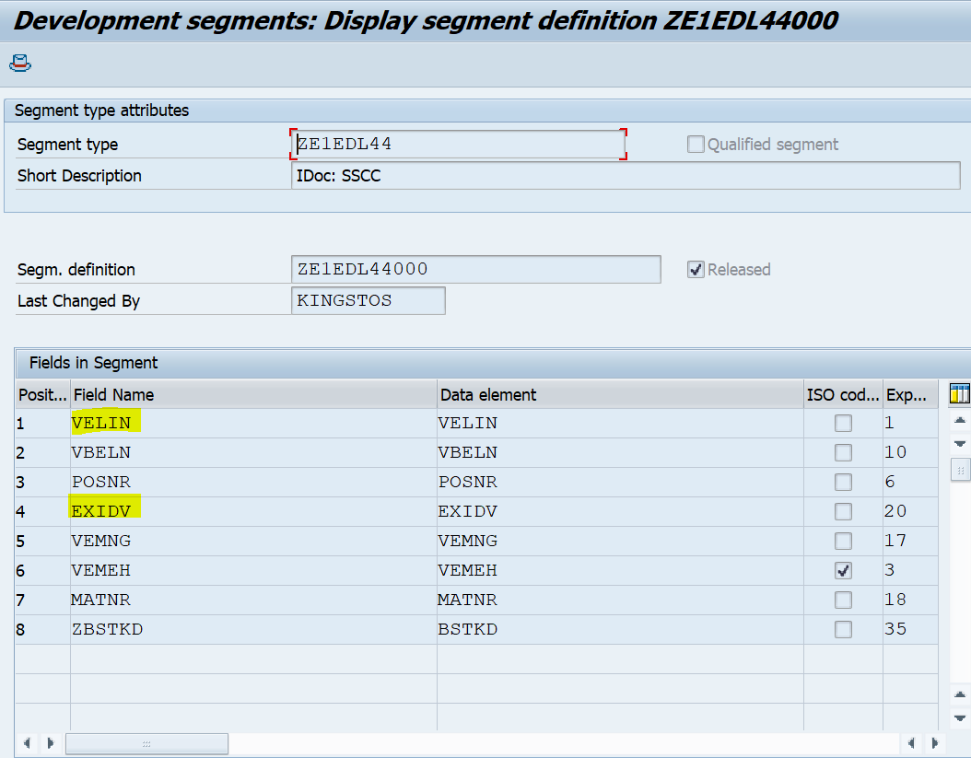

## Mapping enhancements:

|  |  |  |  |  |  |  |  |  |  |  |  |  |  |  |  |  |  |  |  |  |  |  |  |  |  |  |  |  |  |  |  |  |  |  |  |  |  |  |  |  |  |  |  |  |  |  |  |  |  |  |  |  |  |  |  |  |
| --- | --- | --- | --- | --- | --- | --- | --- | --- | --- | --- | --- | --- | --- | --- | --- | --- | --- | --- | --- | --- | --- | --- | --- | --- | --- | --- | --- | --- | --- | --- | --- | --- | --- | --- | --- | --- | --- | --- | --- | --- | --- | --- | --- | --- | --- | --- | --- | --- | --- | --- | --- | --- | --- | --- | --- | --- |
| * The following partners Amazon US, Bookazine Distribution, B&N college, B&N Trade, Matthew Books, Minnesota Univ B/s, Kansas Uni Invoices, Bookazine Co, CHRISTIAN BOOK DISTRIBUTION, Follett SS, AWBC, B&T US, Cokesbury, LIFEWAY CHRISTIAN RES ECPA are sending carton id in MAN*GM segment of DESADV message. * The following partners Brigham Young Uni, Brodart, Colorado Uni Bookstore, AzTechshops, Cornell Uni Store, Bookcompany LLC & Astoria Book Store are sending Tracking number in MAN*GM segment of DESADV message.  Delivery: 300002325 in (Sx3-420) DESADV idoc : 21731852   **Sample MRS Sheet:**  DESADV idoc: 21783332 Delivery: 300002318 in Sx3-420   INVOIC: Process code: SD09 Function module: IDOC_OUTPUT_INVOIC   * It is the outbound idoc which would be used to send invoice details for the Invoice created in S4 Syste,. It will be sent from SAP to the respective partner via EDI. * It will consists of invoice details like material, qty invoiced, different condition price for the items etc.., * **Message structure:**   + Every header data are mentioned using E1EDK-- segment   + Every line item data are maintained using E1EDP—segment  |  |  | | --- | --- | | INVOIC | E1EDK01--> Has invoice header details like invoice number, currency, payment terms, Billing category, | |  | E1EDKA1--> Has partner details AG- Sold-to party; RE- Bill-to; RG- Payer; WE- Ship-to; RS- Invoicing party; BK- Company code details | |  | E1EDK02--> Has document details with date 001- Customer PO; 002- Sales order; 009- Invoice; 012- Delivery; 017 & 087 - Invoice | |  | E1EDK03--> Date 001- Delivery date; 011- Idoc creation date; 012- Invoice date; 028- Due date; 026- Billing date for printout; 048- Exchange rate date | |  | E1EDK04- VAT Indicator ZOTC_1EDK04- condition type & condition base value | |  | E1EDK17- Inco terms data 001- Inco terms1; 002- Incoterms2 | |  | E1EDK18- Payment terms 001- Payment terms; 005- Payment terms description | |  | E1EDK28- Has Details like Bank key, Bank name, Account number | |  | E1EDK14- details like Delivering company code (003); DC(007); Order type(015); Sales org(008); Division(006); Sales doc category(021) | |  | E1EDP01- Contains Item details like Gross price, discounts, net price, tax etc.. | |  | E1EDP02- Data 001- Cust PO; 002- Sale order; 016- Preceding doc(delivery); | |  | E1EDP03- Dates 001- Delivery date; 011- Idoc creation, 022- PO date; 023- Pricing date; 025- Invoice date; | |  | E1EDP19- Material 002 & 003- Material number | |  | E1EDP26- Price 001- Gross price; 002- Gross value; 003- Net value; 010- Subtotal 1; 011- subtotal 2 | |  | E1EDP05- Gross price | |  | E1EDS01- Summation  001- Item count; 012- discount qualified amount; 005- sales tax total; 011- Biilled value; 010- Net invoice value. |   **Sample Idoc:** Idoc 3908947 in Sx3-420 (Del. Number: 530000041)    **Partner profile:**  Partner type: KU Enhancements: In the current environment Z table ZOUPDEF has been maintained the value to validiate or creation or populate the Z Segment - ZE1INV03A(Taric summary), in the IDoc type INVOIC with extension(ZINVOIC) with respect to the field ZUSAGE * ZSD_INVOICE) and ZKEY ( INSPECTION) in the To-Be environment, the Similar values as above will be used BRF+ table.  In the To-Be environment, the Similar values as above will be used Z table.   * Read all the material code in the Invoice document and based on number of commodity code is associated with an ISBN or material, then populate the No of Z-Segment (ZE1INV03A) and summarize all the values in the below mentioned fields which is belongs one commodity code. * The Taric summary header segment (ZE1NV03A) gets the data from the trade/customs tab in the invoice.   A custom segment for Taric summary (ZE1INV03A) needs to be created to update the data from the trade/customs tab from the invoice.  The above custom segment reads all the material code in the Invoice based on Net value, sales units/Billing qty and Net weight of the of Invoice and system will calculate the fright and its update in Invoice and in taric segment.  The below fields needs to be updated in Z-Segement ZE1INV03A   |  |  |  | | --- | --- | --- | | Field Name | Field Description | Width | | QUALF | TARS | 3 | | KWERTN | Condition value | 15 | | STAWN | Commodity Code/Import Code Number for Foreign Trade | 15 | | TARDESC | Text Line | 132 | | KWMENG | Cumulative Order Quantity in Sales Units | 17 | | NTGEW | Net Weight | 15 | | HERKL | Country of origin of the material | 37 |      * In the populated Z-segement, summarize all the above field values belongs one commodity code.   An custom segment Z1EDK04 needs to be created under parent segment E1EDK04 to populate the tax segments value from the invoice header items (Condition type ZITR). This segement contains two fields as below(already created in S4 HANA).  1).ZZKSCHL  2).ZZKAWRT  An custom segment Z1EDP04 needs to be created under parent segment E1EDP04 to populate the tax segments value from the invoice line items (condition type ZITR). This segment contains two fields as below (already created in S4 HANA).  1).ZZKSCHL  2).ZZKAWRT  A custom segment Z1EDKA1 needs to be created under parent segment E1EDKA1 to generate the new segment and fill this segment value from customer master attribute 5 value should be E.which was maintain in customer master general data attribute5 field,if the partner is RG and this partner should be maintain in KNA1 table then this segment/logic will trigger other wise its not trigger.this segement contains one field as below.  1). ZZKATR5  Enhance Segment - E1EDP19 with field name – MFRPN and fill the details as per below logic:  Get the details of table - MARA field - ZZ1_IDENTIFICATIONCODE_PRD (which is 10 digit code) whose ID code Type (i.e. Table - MARA field - ZZ1_IDCODETYPE_PRD)  Pass above values into segment E1EDP19 field MFRPN, when qualifier is “001 and 002”.  **For CR_128: New EDI Partner creation “Barnes & Nobles College”**   * New EDI Partner to be created for “Barnes & Nobles College” & INVOIC message type to be maintained as a part of CR_128  Enhancement for Batch.co.uk: If KNA1 - KATR5 (Acc of Batch) value is “Z” (Batch) for Partner “RE” (Bill to Party) in the invoice, then we need to populate / replace Recipient Partner number (EDIDC-RCVPRN) in INVOIC message type IDOC as “GPBATCHUK” from user exit enhancement.  Sample MRS: |
|  |
|  |